DeLancey, Dayle B. “Vaccinating Freedom: Smallpox Prevention and the Discourses of African American Citizenship in Antebellum Philadelphia.” Journal of African American History 95, no. 3/4 (Summer/Fall 2010): 296-321.
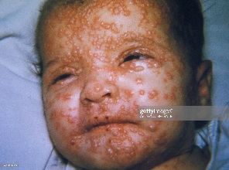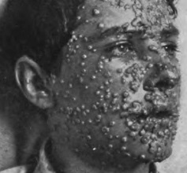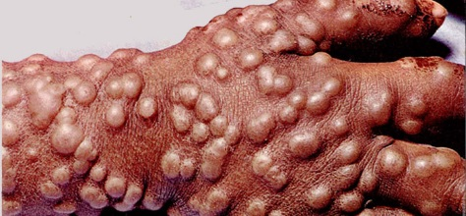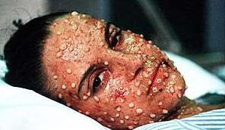
What did “fit for freedom” mean for abolitionists and northern African Americans? How did smallpox vaccination indicate this fitness? How did vaccination = freedom and smallpox = slavery?

How did whites’ view of blacks’ “inherent shortcomings” support restrictions on civil rights and liberties in the North (as well as allowance of kidnappings [see Wilson, “’The Thought of Slavery Is Death to a Free Man’: Abolitionists’ Response to the Kidnapping of Free Blacks”] and the existence of slavery in the South?

How did vaccination demonstrate intelligence and civic responsibility?

How easily did the black and abolitionist press’s efforts reach Philadelphia African American residents?

The abolitionist press promoted slave breeding as an essential element of slavery (Smithers, “American Abolitionism and Slave-Breeding Discourse: A Re-evaluation”) and lack of access to vaccination as a sign of slaves’ inability to control their own bodies. What did these positions say about the effort against slavery and racism?

Note references to kidnappings, Julie Winch, black convention movement, Irish immigration, Absalom Jones and Richard Allen, yellow fever epidemic, Solomon Northrop (Twelve Years a Slave), and medical/scientific advances.

